MindOverMatter

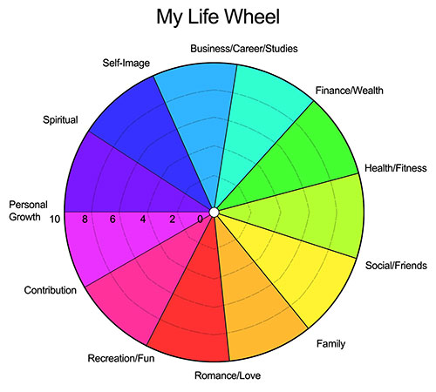
Write down the 3 biggest reasons why your life wheel looks like this?

__________________________________________________________________________________________________________________________________________________________________________________________________________________________________________________________________________________________________________________________________________________________________________________________________________________________

What are your lowest scores and why?
__________________________________________________________________________________________________________________________________________________________________________________________________________________________________________________________________________________________________________________________________________________________________________________________________________________________

Are you happy with your wheel? ______________________________________________________________________________________________________________________________________________________________________________________________________________________________________________________

ACTION
- What are your biggest priorities moving forward to achieve your ideal 10/10 wheel?
__________________________________________________________________________________________________________________________________________________________________________________________________________________________________________________________________________________________________________________________________________________________________________________________________________________________
- What are your biggest actions that will help you achieve your goals?
__________________________________________________________________________________________________________________________________________________________________________________________________________________________________________________________________________________________________________________________________________________________________________________________________________________________

TIPS: Set SMART GOALS, Bite Sized Chunks, Reflect and Understand how you came to be where you are. Take one step at a time.

